**Step 1: Create the Form to Set the Cookie**

First, we need to create an HTML form to get the user's name, which we will then store in a cookie.

**Step 2: Set the Cookie in PHP**

Once the user submits the form, we need to capture the name and store it in a cookie.

* **setcookie**: We use setcookie() to store the user’s name in a cookie that will last for 30 days.
* After setting the cookie, we redirect the user to welcome.php where we will display their name.

**Step 3: Display the Cookie Value (Welcome Page)**

This is the page that greets the user by displaying their name stored in the cookie. It also gives the option to clear the cookie.

* **Cookie Check**: We first check if the username cookie is set. If it exists, we greet the user with their name. If not, we redirect them back to the form.
* **Clear Cookie Link**: This page also contains a link to clear the cookie.

**Step 4: Clear the Cookie (Logout)**

**Step 5: Test the Application**

1. **Place the files:**
   * **Place index.html, set_cookie.php, welcome.php, and clear_cookie.php in the same directory in your server (local or live).**
2. **Start the local server:**
   * **Make sure that Apache is running in your local XAMPP or WAMP environment.**
3. **Access the form:**
   * **Open the index.html page (http://localhost/index.html).**
4. **Test setting the cookie:**
   * **Enter your name and submit the form. You should be redirected to the welcome page where you see the greeting message.**
5. **Clear the cookie:**
   * **Click the Clear Cookie link, and you should be redirected to the input form, indicating that the cookie was successfully deleted.**

**Output:**

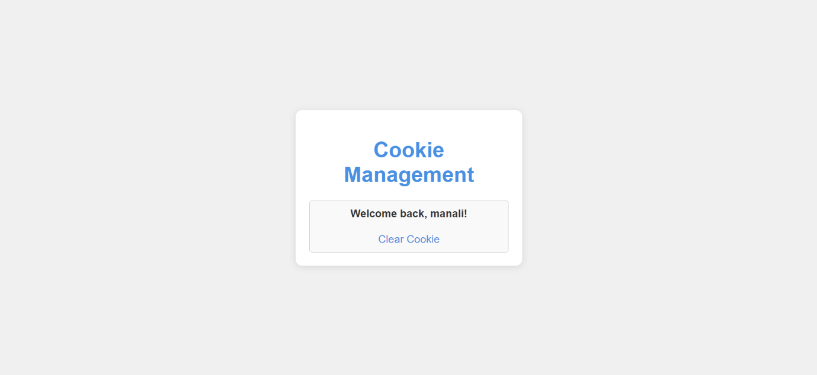

To allow the user to clear the cookie, we need a script that will delete the cookie and redirect the user back to the input form.